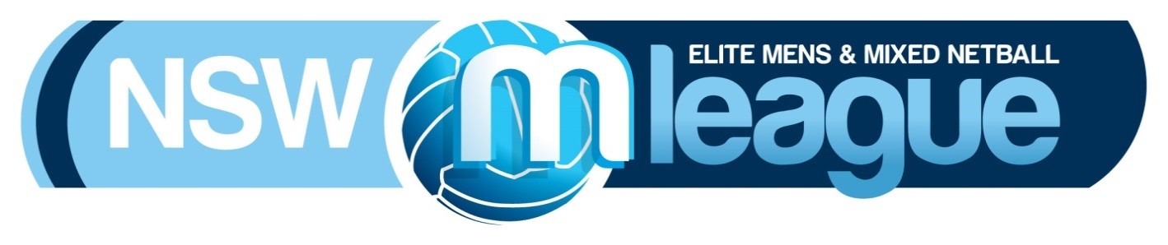

2017 team registration form

team name:

team Delegate:
Name:
Address:

Suburb: |  |  | State: |  |  | Postcode:
Phone: |  |  | Email:

Secondary team delegate:
Name:
Phone: |  | Email:
COMPETITION: Please mark (X)
Men’s Division |  | Mixed Division |  |  |  |  | Junior Division

player details:
NAME |  | DOB |  | MyNetball ID No. |  |  | PHONE | POINTS
Coach Name (if applicable):

team Colours:
Shirt:

PLAYER POINTS TABLE:
A player will carry the points set out in the table below based on the following:

- if a player was selected to represent NSW at the 2017 AMMNA National Championship - that player will carry the points associated with the representative level they participated at the 2017 AMMNA National Championships;

- if a player was not selected to represent NSW at the 2017 AMMNA National Championship, but represented NSW at an AMMNA National Championship in the past three (3) years - that player will carry the points associated with the highest representative level that they played in the last three (3) years; and

- all other players - the player will carry the points associated with their representative level set out in the table below.

Points | Player’s representative level
5 | NSW Open Men
4 | NSW Open Mixed (male and female players)
3 | NSW Men’s Reserve  NSW Under 23s  NSW Mixed Reserve  Premier League Females  All Australian Indoor Representatives
0 | Non MNNSW State Players  Under 20 Premier League Females  Players not selected to represent NSW at an AMMNA National Championship in the last three (3) years, but represented NSW at an AMMNA National Championship more than three (3) years ago  Players that turn 21years old by 31 December 2017
-1 | Players that are 19 to 20 years old  New recruits to MNNSW (this only applies for the first year that player plays in the MLeague Competition)
-2 | Players that are 16 to 18 years old
-3 | Players that are 15 years old and under

Teams are only permitted to have three (3) current NSW Open Mens players registered in their team and only two (2) current NSW Open Men’s players may be on court at any time during a game.

Maximum player points allowed on court at any one time are as follows: Men’s Division: 17 and Mixed Division: 21

Declaration:
I hereby declare that I am authorised to act on behalf of the above mentioned team and that all details provided are true and correct.
- As Team Delegate I confirm that all players listed above are in good health and fitness to compete in the 2017 MLeague Competition.
- We have read and understood the Competition Rules set by Men’s Netball New South Wales and agree to comply with the rules of the game in true spirit and sportsmanship.
- We agree to pay Men’s Netball New South Wales a fee of $1350 being for our participation in the competition for 2017. Competition fees will be paid by a $200 deposit due at the time we submit this registration form with a further $300 being due by Week 1 of the competition and the remaining $850 due by Week 2. If we are not financial by this time we understand we may be removed from the competition.
- We understand that all players must be financial (meaning they do not currently owe MNNSW for any outstanding fees or costs) and registered with Netball NSW via the MyNetball.com.au registration site. Players that are not registered on the site will not be allowed to participate in any games until they are registered due to their lack of injury insurance.

Signature: (Team Delegate)
 |  |  |  |  | Date:

MNNSW CONTACT DETAILS:
All completed Team Registration Forms can be emailed to:  Kelli Douglas  E mensnetballnsw.sec@gmail.com  P 0433 535 329 | Bank Transfer Details:  Mens Netball NSW  BSB - 642170  ACC – 710548

